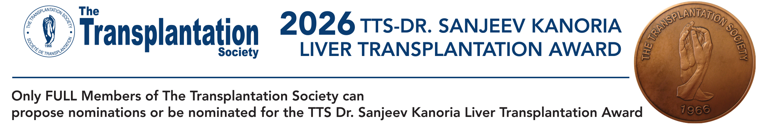

Email this completed form to: nominations@tts.org

PLEASE SEND THE COMPLETED FORM NO LATER THAN MAY 18, 2026

1. NOMINEE DETAILS:

Name of Nominee:
Professional Title and Afﬁliation of Nominee:
Business Address:
Telephone:
Email:

2. NOMINATOR DETAILS:

Name of Nominator:
Professional Title and Afﬁliation of Nominator:
Business Address:
Telephone:
Email:
Signature:

3. A statement highlighting the principal scientiﬁc achievements in liver transplantation of the nominee. (Not to exceed 250 words):

4. A brief curriculum vitae or biographical sketch of the nominee. (Not to exceed 500 words):

5. A list containing the most signiﬁcant scientiﬁc publications in liver transplantation relevant to the nominee (not to exceed 10 citations). Please include the authors (with the name of the nominee in Bold, title, journal, year, volume and pages).

6. How many years has the nominee been active in the field of liver transplantation?

7. Has the nominee contributed to TTS? (e.g., volunteer roles, TTS journals, congress involvement or other) If so please summarize top contributions to the society (not to exceed 10 activities).

OPTIONAL

7. Funding History

Please list top 10 competitive research grants for which you served as the Principal Investigator or Co-Investigator, including the funding agency, project title, role, total amount and funding period.

Recognizing that funding mechanisms and award sizes vary across countries and institutions, nominations may include brief contextual information if helpful.

8. Diversity and Professional Context Information
Information about the nominee’s experiences or circumstances that have may have influenced their professional opportunities. This may include experiences related to gender, racial or ethnic minority, disability, working in resource-limited settings, or other relevant factors.

